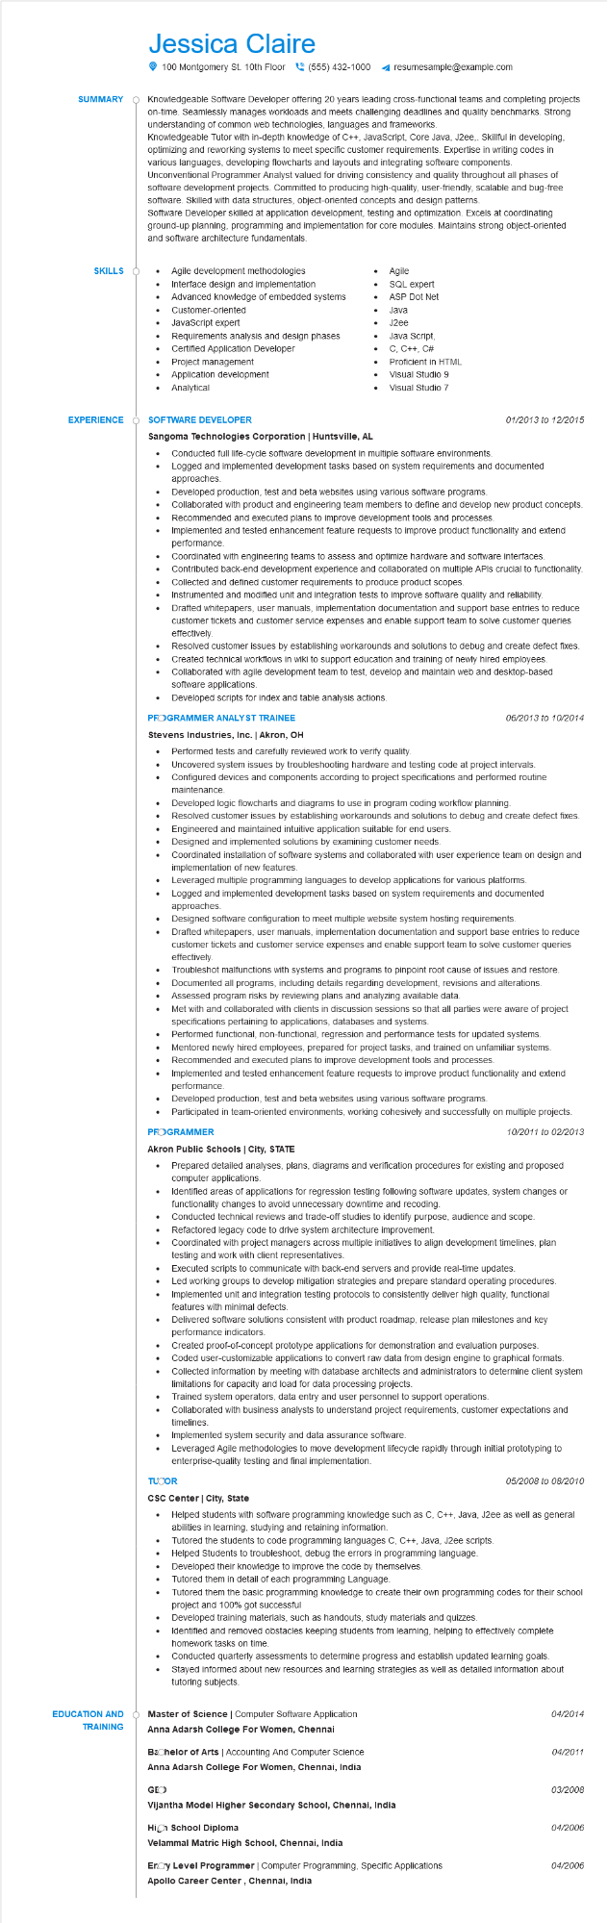
Jessica Claire
SUMMARY
100 Montgomery St. 10th Floor(555) 432-1000
resumesample@example.com
Knowledgeable Software Developer offering 20 years leading cross-functional teams and completing projects on-time. Seamlessly manages workloads and meets challenging deadlines and quality benchmarks. Strong understanding of common web technologies, languages and frameworks.
Knowledgeable Tutor with in-depth knowledge of C++, JavaScript, Core Java, J2ee,. Skillful in developing, optimizing and reworking systems to meet specific customer requirements. Expertise in writing codes in various languages, developing flowcharts and layouts and integrating software components. Unconventional Programmer Analyst valued for driving consistency and quality throughout all phases of software development projects. Committed to producing high-quality, user-friendly, scalable and bug-free software. Skilled with data structures, object-oriented concepts and design patterns.
Software Developer skilled at application development, testing and optimization. Excels at coordinating ground-up planning, programming and implementation for core modules. Maintains strong object-oriented and software architecture fundamentals.
SKILLS
• Agile development methodologies
Interface design and implementation
Advanced knowledge of embedded systems Customer-oriented
•
JavaScript expert
•
Requirements analysis and design phases
Certified Application Developer
•
Project management
·
Application development
•
Analytical
Agile SQL expert
ASP Dot Net
•
Java
J2ee
•
Java Script,
C, C++, C#
Proficient in HTML
Visual Studio 9
Visual Studio 7
EXPERIENCE O SOFTWARE DEVELOPER
Sangoma Technologies Corporation | Huntsville, AL
•
•
....
.....
...
01/2013 to 12/2015
Conducted full life-cycle software development in multiple software environments. Logged and implemented development tasks based on system requirements and documented approaches.
Developed production, test and beta websites using various software programs.
Collaborated with product and engineering team members to define and develop new product concepts. Recommended and executed plans to improve development tools and processes.
Implemented and tested enhancement feature requests to improve product functionality and extend performance.
Coordinated with engineering teams to assess and optimize hardware and software interfaces. Contributed back-end development experience and collaborated on multiple APIs crucial to functionality. Collected and defined customer requirements to produce product scopes.
Instrumented and modified unit and integration tests to improve software quality and reliability. Drafted whitepapers, user manuals, implementation documentation and support base entries to reduce customer tickets and customer service expenses and enable support team to solve customer queries effectively
Resolved customer issues by establishing workarounds and solutions to debug and create defect fixes. Created technical workflows in wiki to support education and training of newly hired employees. Collaborated with agile development team to test, develop and maintain web and desktop-based software applications.
• Developed scripts for index and table analysis actions.
PROGRAMMER ANALYST TRAINEE
06/2013 to 10/2014
Stevens Industries, Inc. | Akron, OH
•
Performed tests and carefully reviewed work to verify quality.
•
Uncovered system issues by troubleshooting hardware and testing code at project intervals. Configured devices and components according to project specifications and performed routine maintenance.
Developed logic flowcharts and diagrams to use in program coding workflow planning.
Resolved customer issues by establishing workarounds and solutions to debug and create defect fixes.
•
Engineered and maintained intuitive application suitable for end users.
•
Designed and implemented solutions by examining customer needs.
•
•
•
•
Coordinated installation of software systems and collaborated with user experience team on design and implementation of new features.
Leveraged multiple programming languages to develop applications for various platforms. Logged and implemented development tasks based on system requirements and documented approaches.
Designed software configuration to meet multiple website system hosting requirements.
Drafted whitepapers, user manuals, implementation documentation and support base entries to reduce customer tickets and customer service expenses and enable support team to solve customer queries effectively.
Troubleshot malfunctions with systems and programs to pinpoint root cause of issues and restore. Documented all programs, including details regarding development, revisions and alterations. Assessed program risks by reviewing plans and analyzing available data.
Met with and collaborated with clients in discussion sessions so that all parties were aware of project specifications pertaining to applications, databases and systems.
•
Performed functional, non-functional, regression and performance tests for updated systems.
•
Mentored newly hired employees, prepared for project tasks, and trained on unfamiliar systems. Recommended and executed plans to improve development tools and processes.
•
Implemented and tested enhancement feature requests to improve product functionality and extend performance.
Developed production, test and beta websites using various software programs.
Participated in team-oriented environments, working cohesively and successfully on multiple projects.
PROGRAMMER
Akron Public Schools | City, STATE
10/2011 to 02/2013
• Prepared detailed analyses, plans, diagrams and verification procedures for existing and proposed computer applications.
Identified areas of applications for regression testing following software updates, system changes or functionality changes to avoid unnecessary downtime and recoding.
Conducted technical reviews and trade-off studies to identify purpose, audience and scope.
•
Refactored legacy code to drive system architecture improvement.
Coordinated with project managers across multiple initiatives to align development timelines, plan testing and work with client representatives.
Executed scripts to communicate with back-end servers and provide real-time updates.
•
Led working groups to develop mitigation strategies and prepare standard operating procedures. Implemented unit and integration testing protocols to consistently deliver high quality, functional features with minimal defects.
•
Delivered software solutions consistent with product roadmap, release plan milestones and key performance indicators.
Created proof-of-concept prototype applications for demonstration and evaluation purposes.
•
Coded user-customizable applications to convert raw data from design engine to graphical formats.
Collected information by meeting with database architects and administrators to determine client system limitations for capacity and load for data processing projects.
Trained system operators, data entry and user personnel to support operations.
Collaborated with business analysts to understand project requirements, customer expectations and timelines.
•
Implemented system security and data assurance software.
• Leveraged Agile methodologies to move development lifecycle rapidly through initial prototyping to enterprise-quality testing and final implementation.
TUCOR
05/2008 to 08/2010
CSC Center | City, State
Helped students with software programming knowledge such as C, C++, Java, J2ee as well as general abilities in learning, studying and retaining information.
Tutored the students to code programming languages C, C++, Java, J2ee scripts.
•
Helped Students to troubleshoot, debug the errors in programming language.
Developed their knowledge to improve the code by themselves.
Tutored them in detail of each programming Language.
Tutored them the basic programming knowledge to create their own programming codes for their school project and 100% got successful
Developed training materials, such as handouts, study materials and quizzes.
Identified and removed obstacles keeping students from learning, helping to effectively complete homework tasks on time.
Conducted quarterly assessments to determine progress and establish updated learning goals. Stayed informed about new resources and learning strategies as well as detailed information about tutoring subjects.
EDUCATION AND TRAINING
Master of Science | Computer Software Application
04/2014
Anna Adarsh College For Women, Chennai
Bachelor of Arts | Accounting And Computer Science
Anna Adarsh College For Women, Chennai, India
04/2011
GEO
03/2008
Vijantha Model Higher Secondary School, Chennai, India
High School Diploma
04/2006
Velammal Matric High School, Chennai, India
Eroy Level Programmer | Computer Programming, Specific Applications
04/2006
Apollo Career Center, Chennai, India

